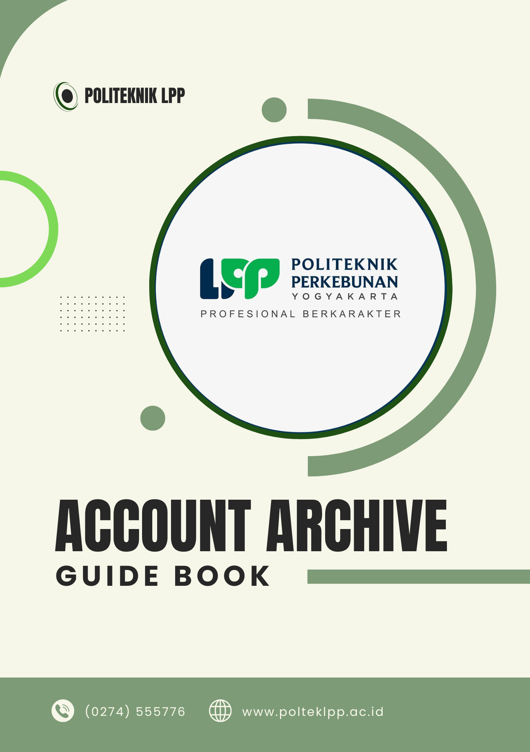

DAFTAR ISI

DAFTAR ISI 3
ADMINISTRATOR PC LAB KOMPUTER 5
OBSERVIUM 5
MIKROTIK WINBOX 6
AKUN SUPER ADMIN 6
APLIKASI CONTROLLER 7
AKUN PUSKOM 8
AKUN REPOSITORY 8
AKUN ARCHIVE 8
AKUN SERVER – SERVER 9
WEB HOSTING NIAGAHOSTER 13
WEB HOSTING CITRANET 15
ANYDESK PC SERVER 15
TOPOLOGI JARINGAN INTRANET POLTEK LPP 17
MONITORING OBSERVIUM 18
SETTING BARDI IP CAM 19
SETTING RUIJIE AP DAN SWITCH 20
SETTING NEW DEVICE UNIFI 21

ADMINISTRATOR PC LAB KOMPUTER
Admin PC Lab Komputer Utara
Administrator PC 13 : @PoltekLPP1997
Administrator PC 22 : @PoltekLPP1997

Admin PC Lab Komputer Selatan
Administrator PC 30 : @PoltekLPP1997#

OBSERVIUM
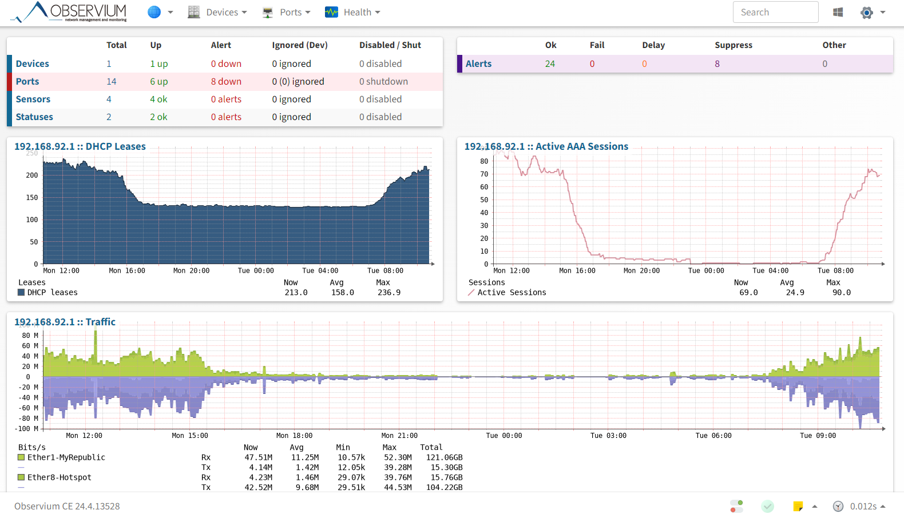
Server Ubuntu Observium
IP Address : 192.168.88.131/24
User Ubuntu : polteklpp
Password : polteklpp1997

Database Observium
db_name : observiumdb
db_user : observiumuser
db_pass : Polteklpp1997#

Monitoring Observium
IP Address : 103.129.174.21:90
Username : admin
Password : @PoltekLPP1997#

Any Desk PC Server Observium
ID : 1493609440
Password : @PoltekLPP1997#

ARSIPBAAK (EFILING)
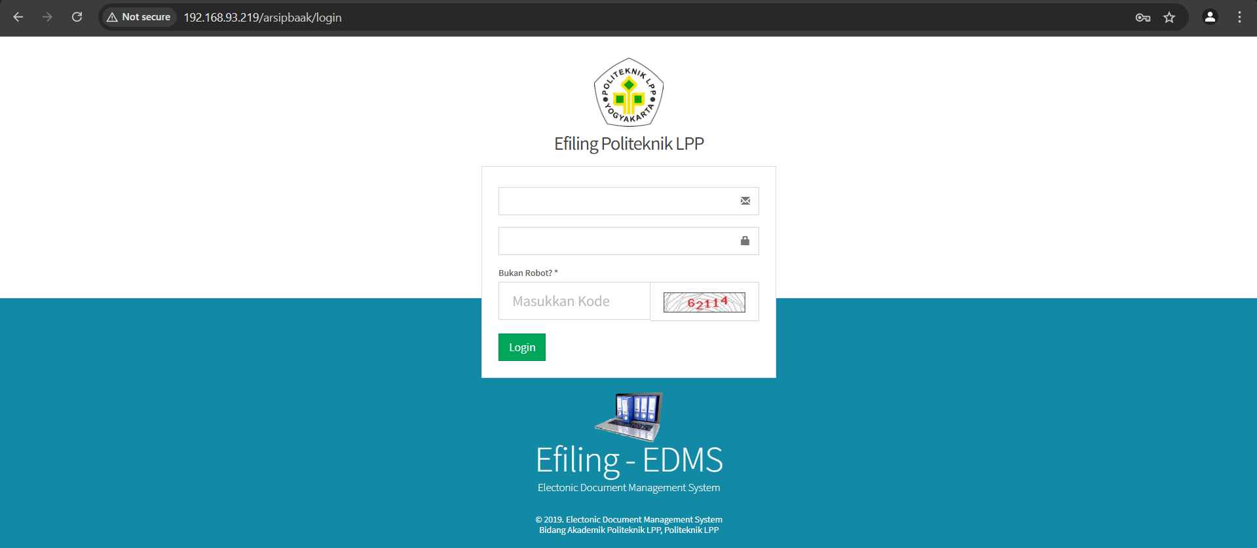
Server Ubuntu arsipbaak (efiling)
IP Address : 192.168.88.128/22
User Ubuntu : arsipbaak
Password : @PoltekLPP1997

Database Efiling
db_name : dbefiling
db_user : admin
db_pass : polteklpp

Akses Efiling
IP Address : 192.168.88.128/arsipbaak
IP Public : 103.129.174.22:8080/arsipbaak
Username : menyesuaikan (admin)
Password : menyesuaikan (admin)

MIKROTIK WINBOX
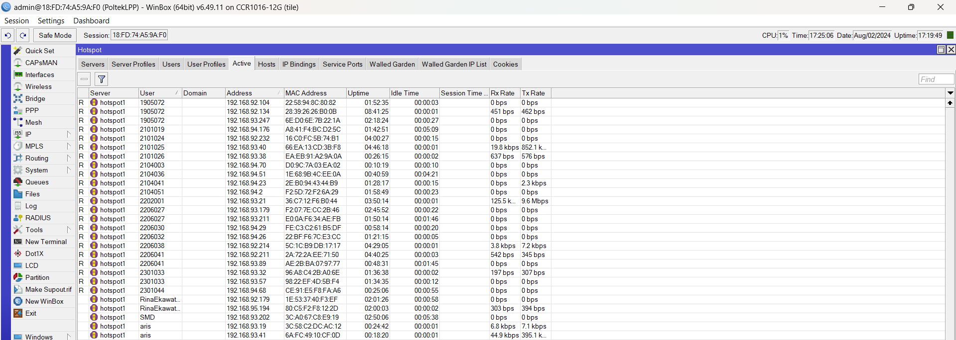
Login Winbox
MAC ADD : 18:FD:74:A5:9A:F0
Login : admin
Password : Ltech123//

MIKROTIK USERMAN
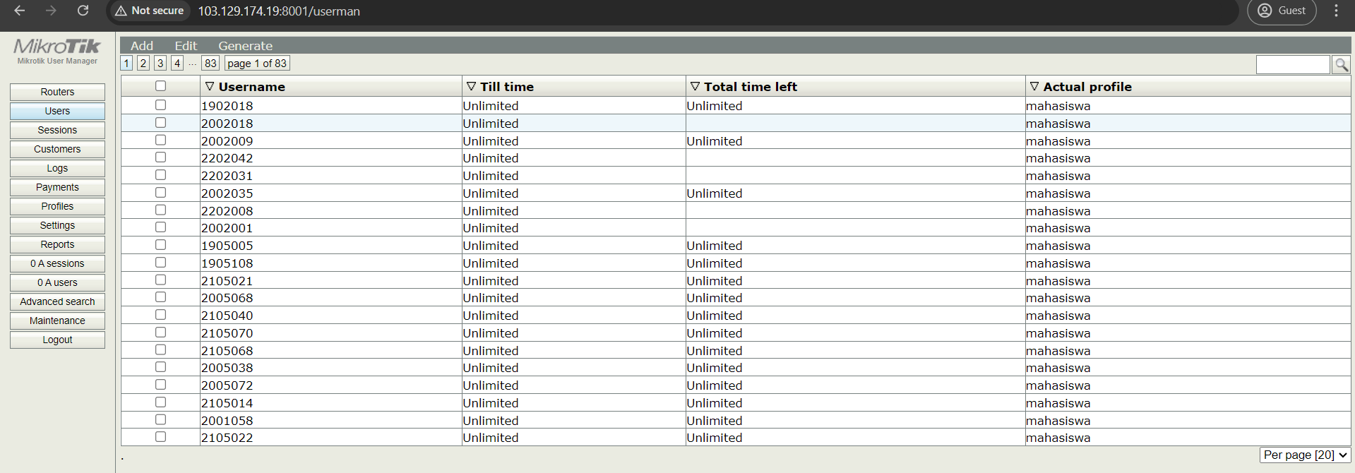
Login Winbox
Akses : http://103.129.174.19:8001/userman
Username : admin
Password : Ltech123//

AKUN SUPER ADMIN
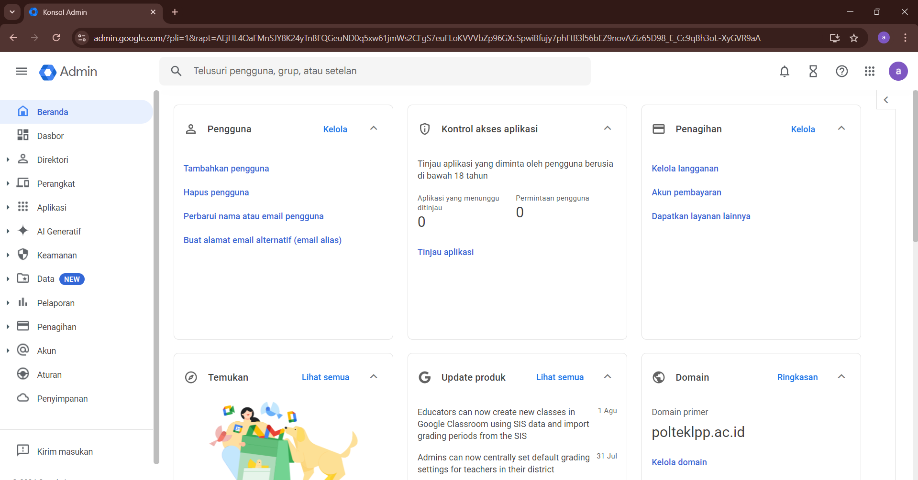
Super Admin
Akses : admin.google.com
Email : poltekmail@polteklpp.ac.id
Password : @PoltekLPP97
SuperAdmin untuk mengelola domain Poltek.

APLIKASI CONTROLLER
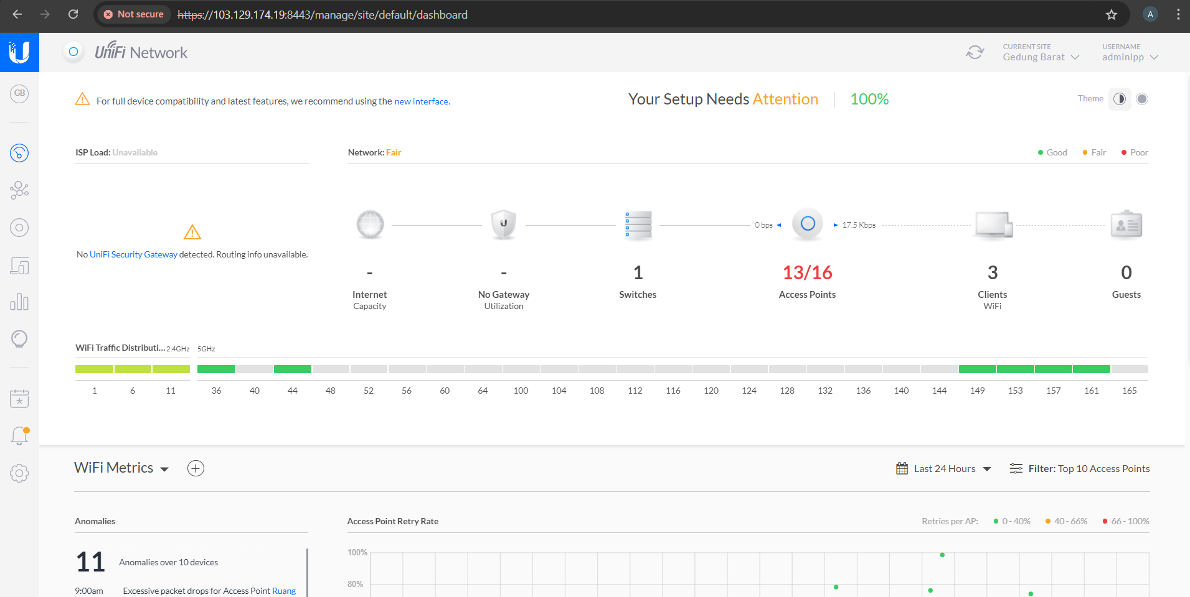
Aplikasi Controller Unifi
Akses : https://192.168.92.121:8443
IP Public : https://103.129.174.19:8443
Username : adminlpp
Password : kembar111091

Desktop Controller Unifi Ubiquity
Login Windows : PoltekLPP97

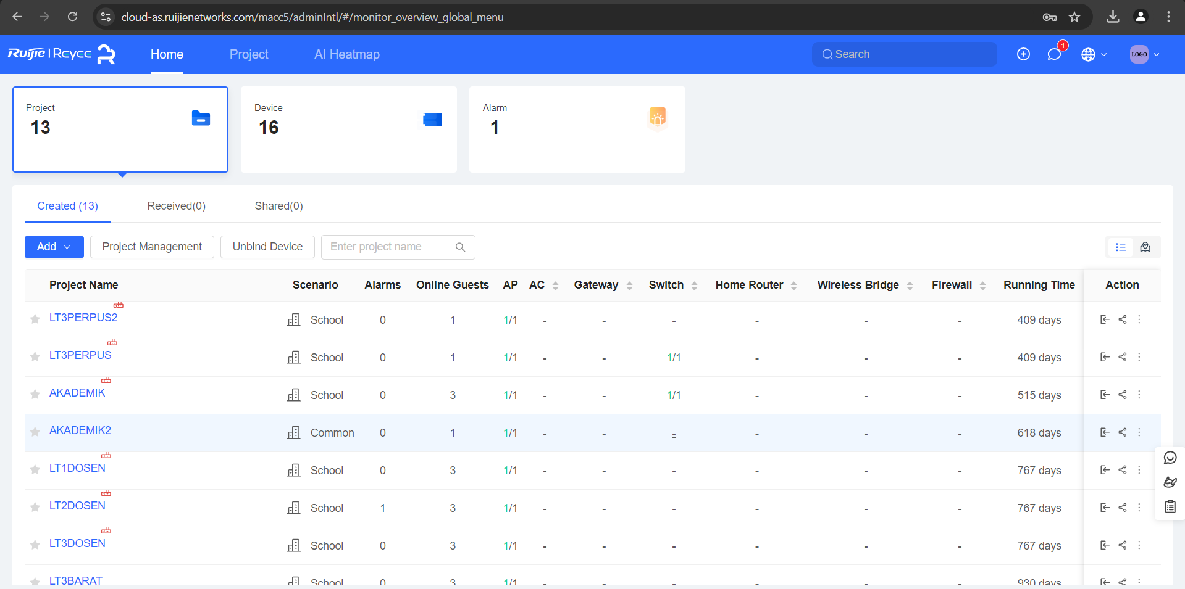
Aplikasi Controller Ruijie
Akses : cloud-as.ruijienetworks.com
Username : mikrotikpolteklpp@gmail.com
Password : kembar111091
Remote dengan eWeb

AKUN PUSKOM
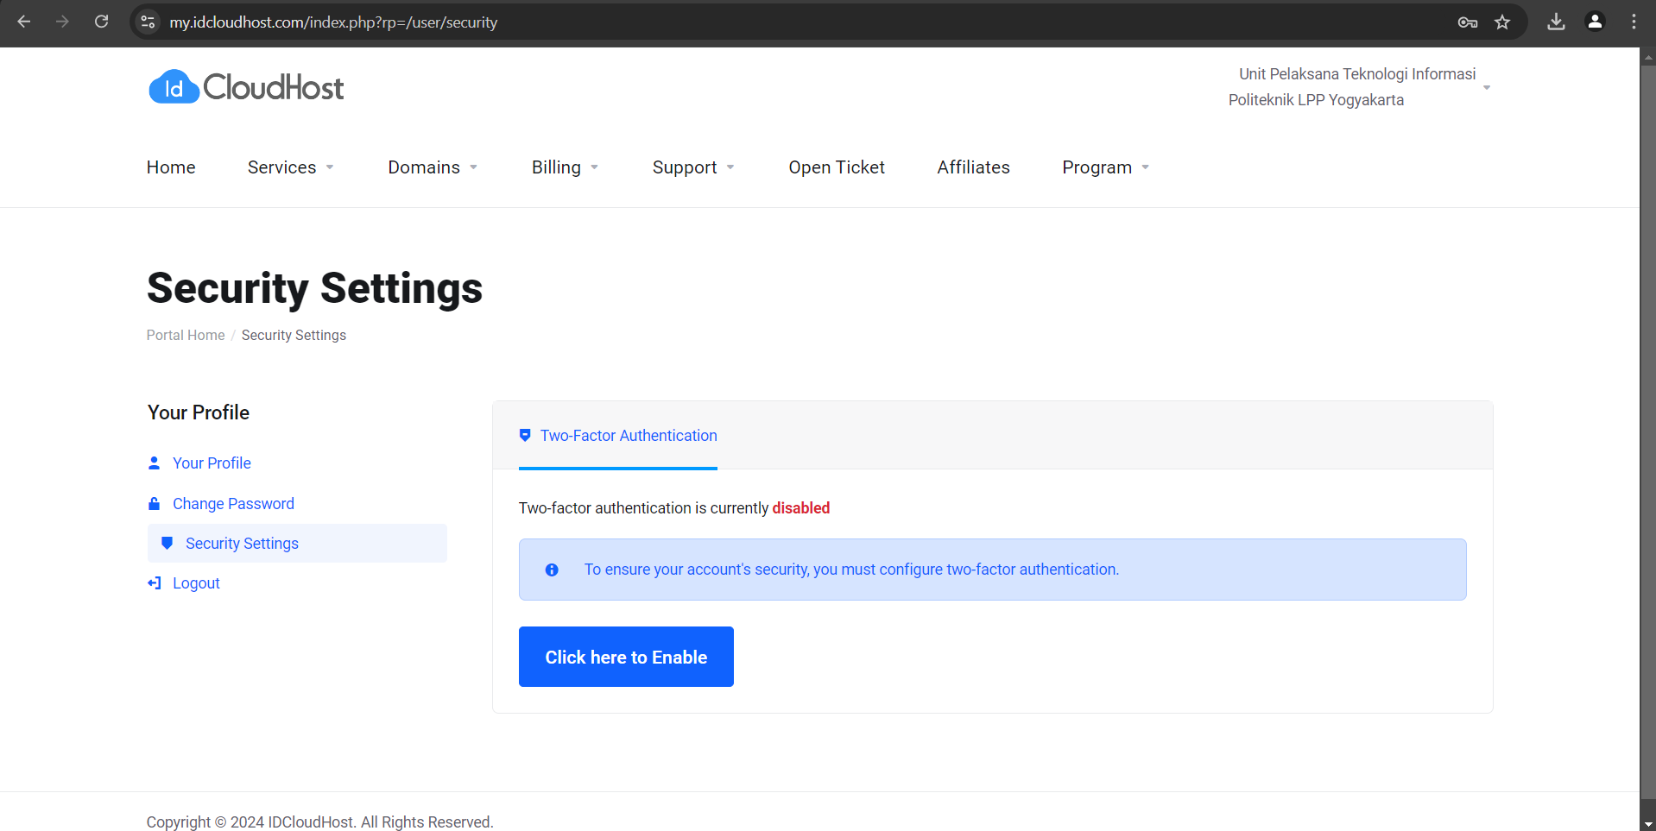
Puskom
Akses Login : IDCloudHost
Email : puskom@polteklpp.ac.id
Password : @PoltekLPP1997

AKUN REPOSITORY
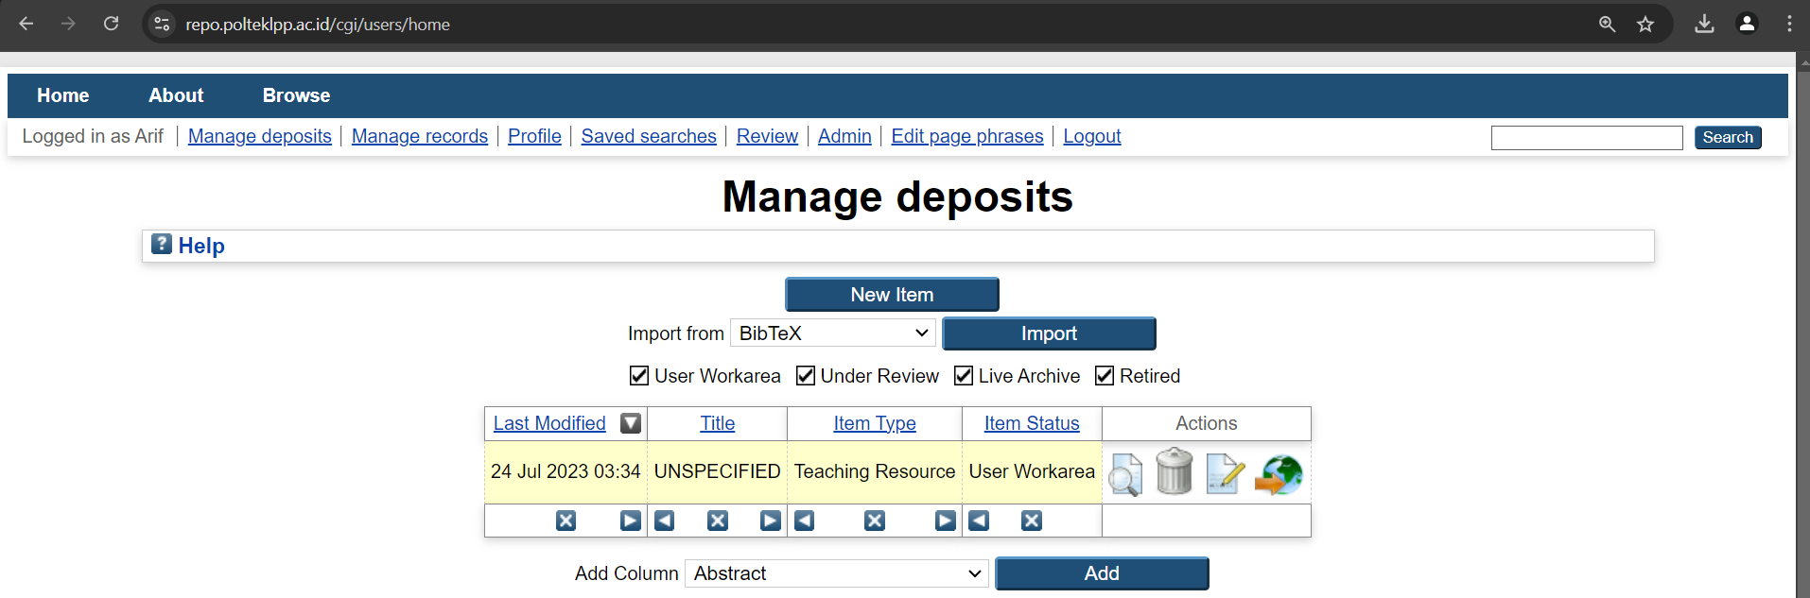
Repository
Akses : repo.polteklpp.ac.id
Username : admin
Password : @PoltekLPP97

AKUN ARCHIVE
Archive
Email : archive@polteklpp.ac.id
Password : newbaak2020

AKUN SERVER – SERVER
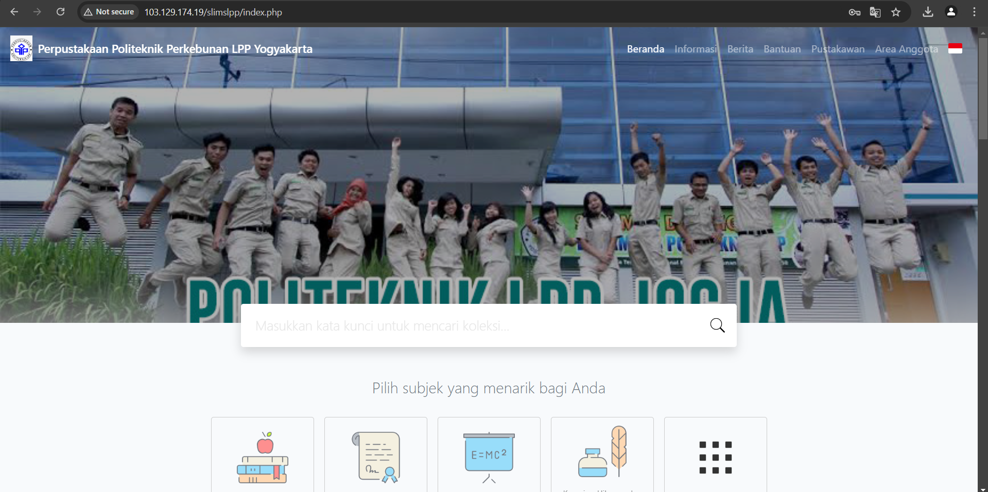
Server Perpustakaan
Akses : 192.168.88.8/slimslpp
IP Public : 103.129.174.19/slimslpp
Username : admin
Password : perpus01

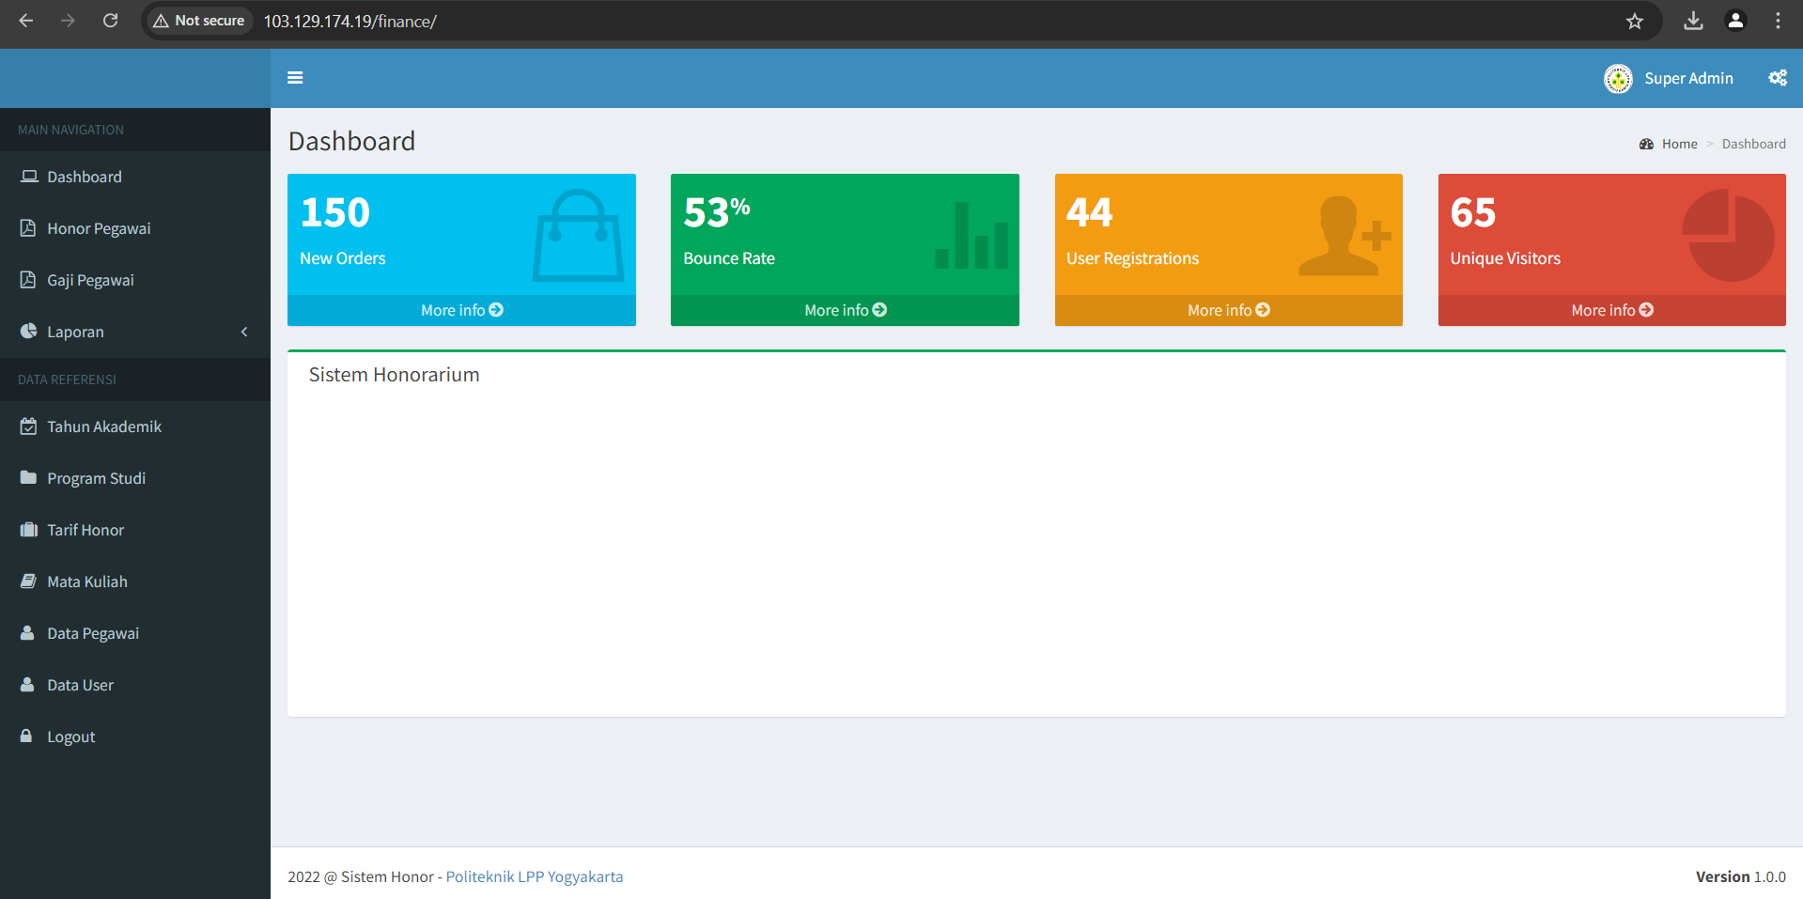
Server Finance
Akses : 192.168.88.8:8080/finance
IP Public : 103.129.174.19:8080/finance
Username : sa@gmail.com
Password : 999999

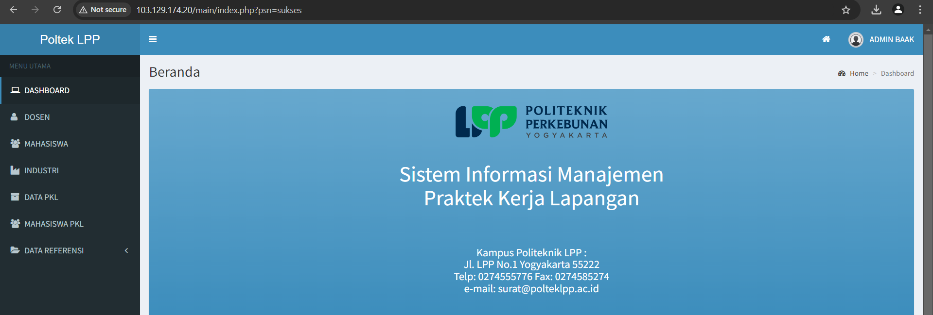
Server SIM PKL
Akses : 192.168.88.127/main
IP Public : 103.129.174.20/main
Username : arh@polteklpp.ac.id
Password : 999999

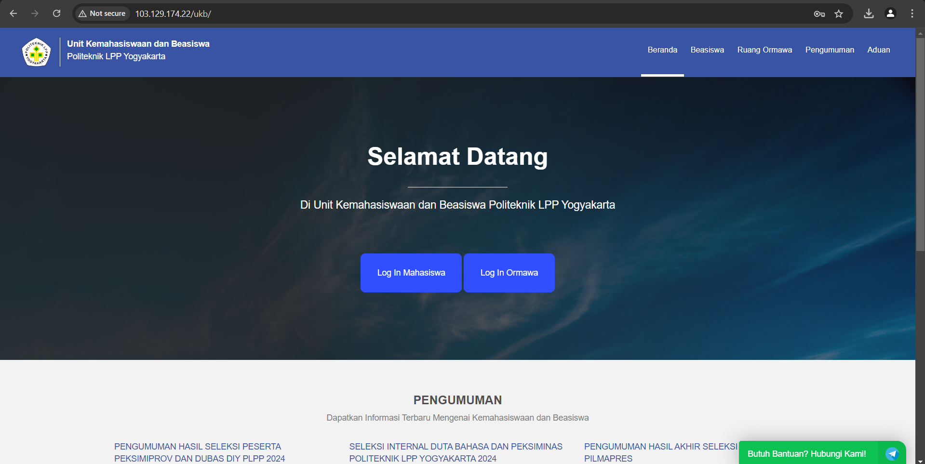
Server Kemahasiswaan
Login Windows : PoltekLPP97
Akses : 192.168.88.253/ukb
IP Public : 103.129.174.22/ukb
Username : sa@gmail.com
Password : 999999

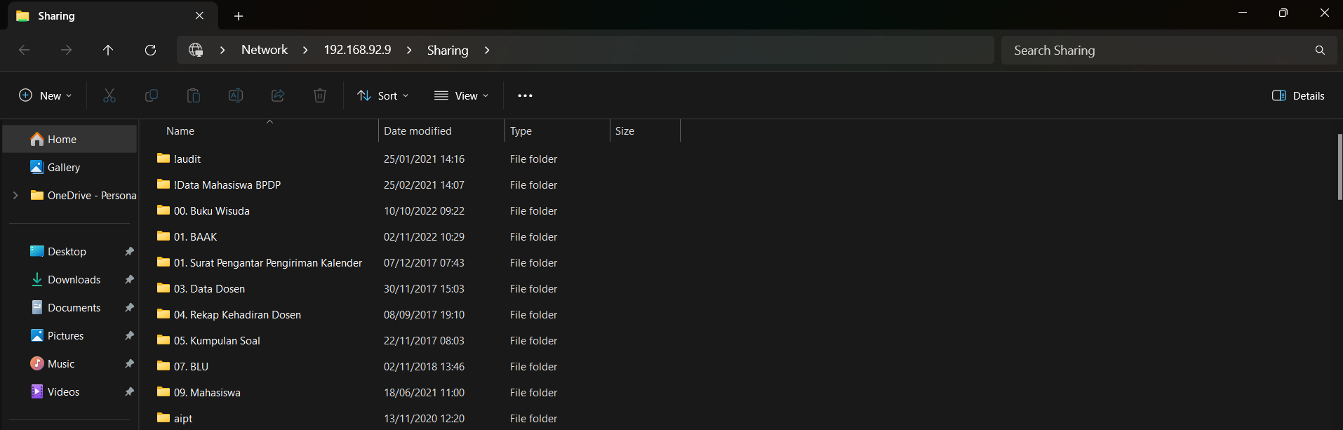
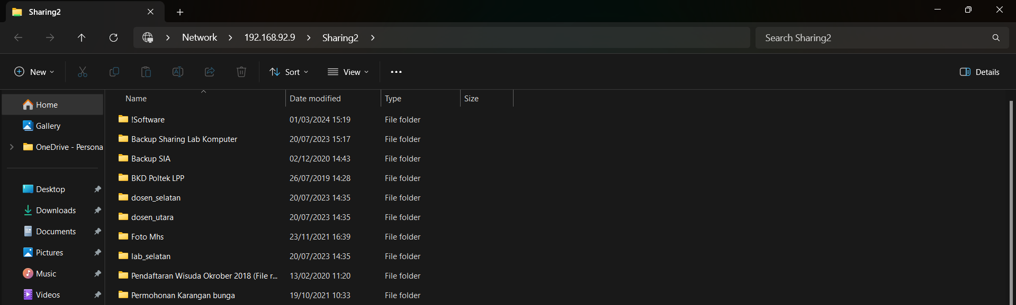
Server Sharing
Akses : \\192.168.92.9\Sharing
\\192.168.92.9\Sharing2
Username : owncloud
Password : lpppoltek

Server Windows
Login : Administrator Desktop
Password : PoltekLPP97

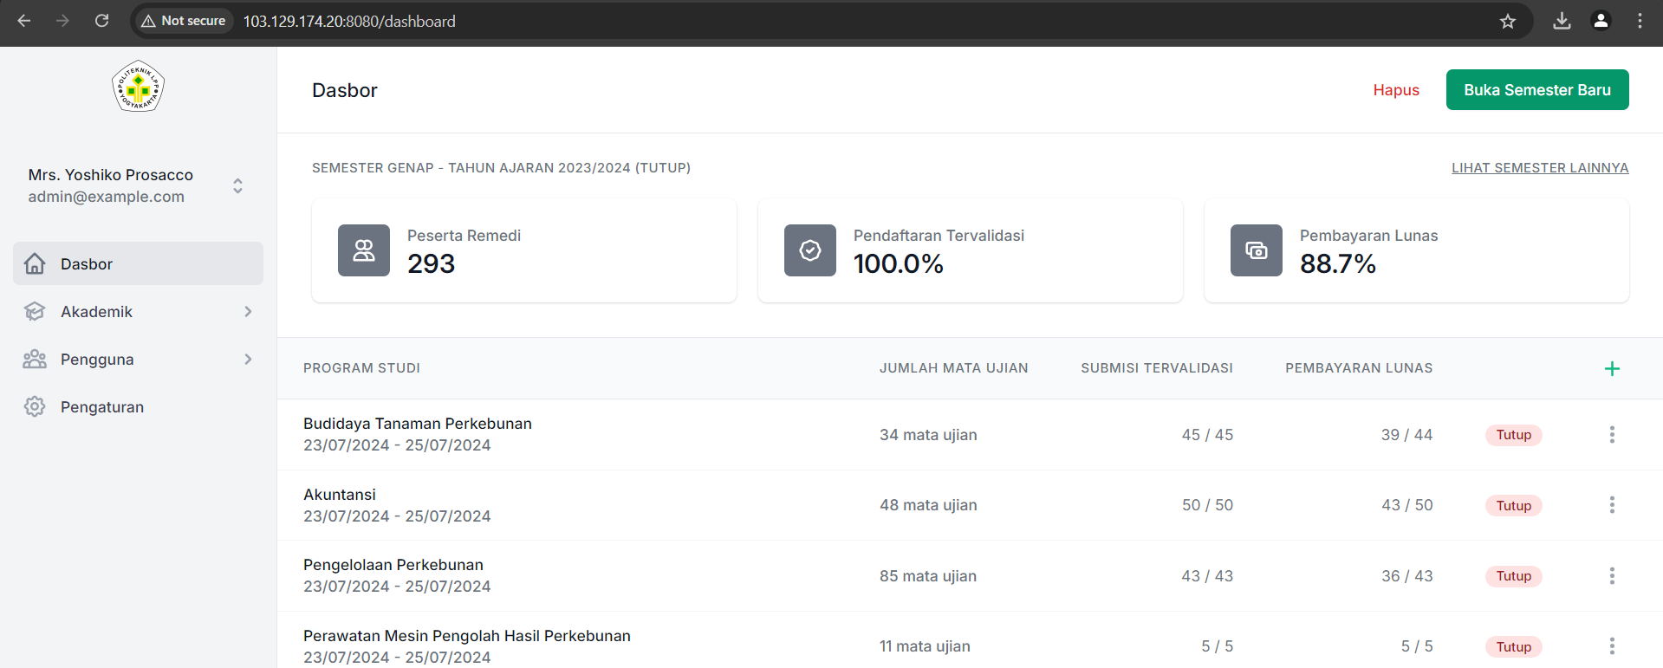
Server SIM Ujian Perbaikan
Akses : 192.168.88.123:8080
IP Public : 103.129.174.20:8080
Login : admin@example.com
Password : password

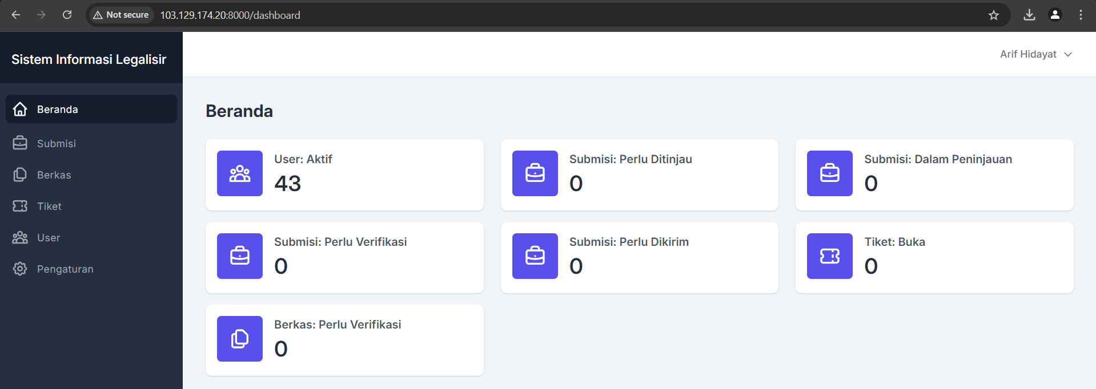
Server SIM Legalisir
Akses :192.168.88.123:8000
IP Public : 103.129.174.20:8000
Login : admin@legalisir.com
Password : password

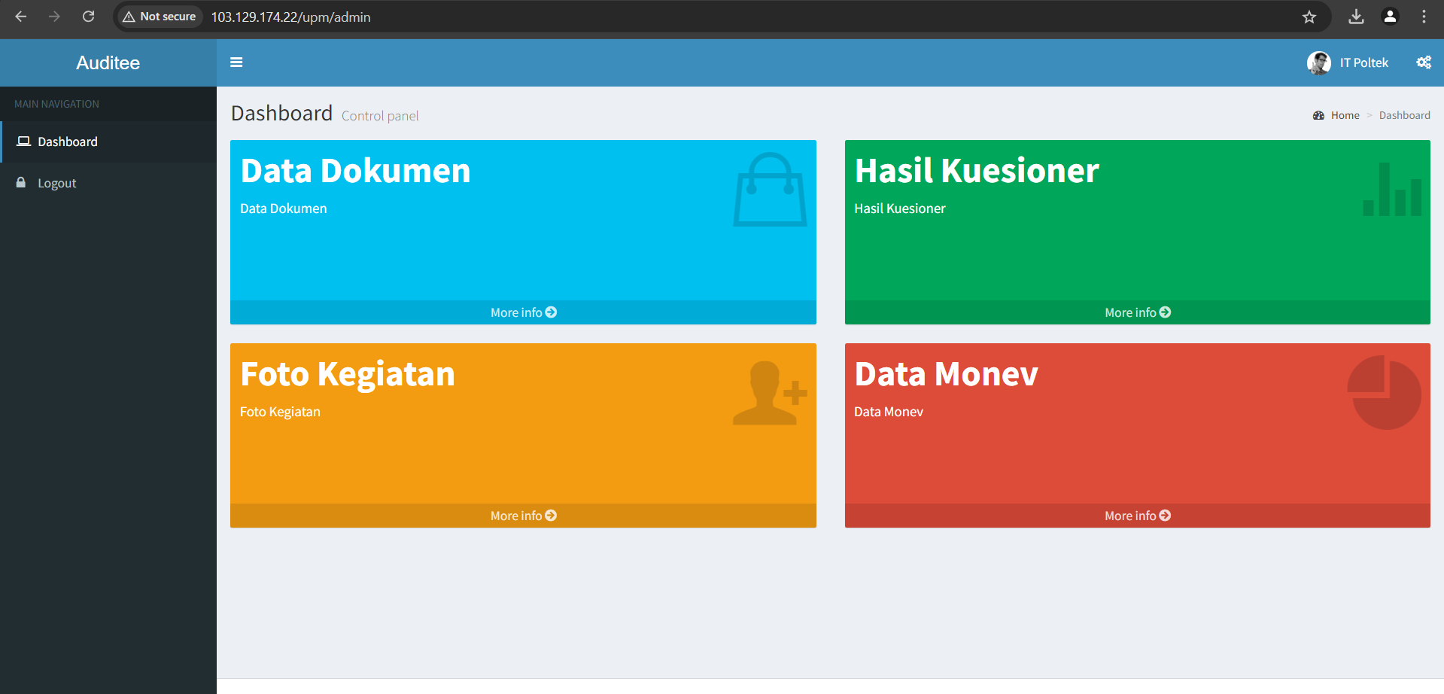
Server SIM UPMPI
Akses : 192.168.88.253/upm
IP Public : 103.129.174.22/upm
Login user : puskom@polteklpp.ac.id
Password : 999999
Login dipegang unit, selain itu user biasa.

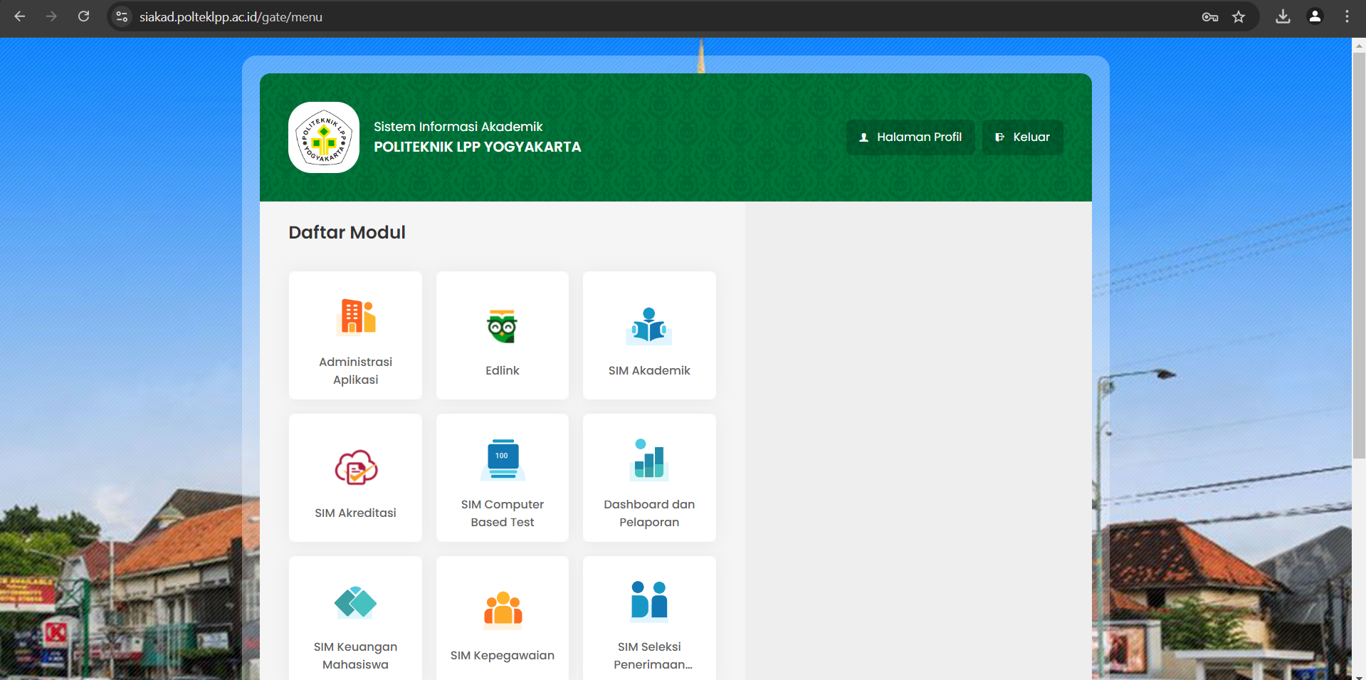
SIAKAD
Akses : siakad.polteklpp.ac.id
User : arh@polteklpp.ac.id
Password : @4zl4n3019#

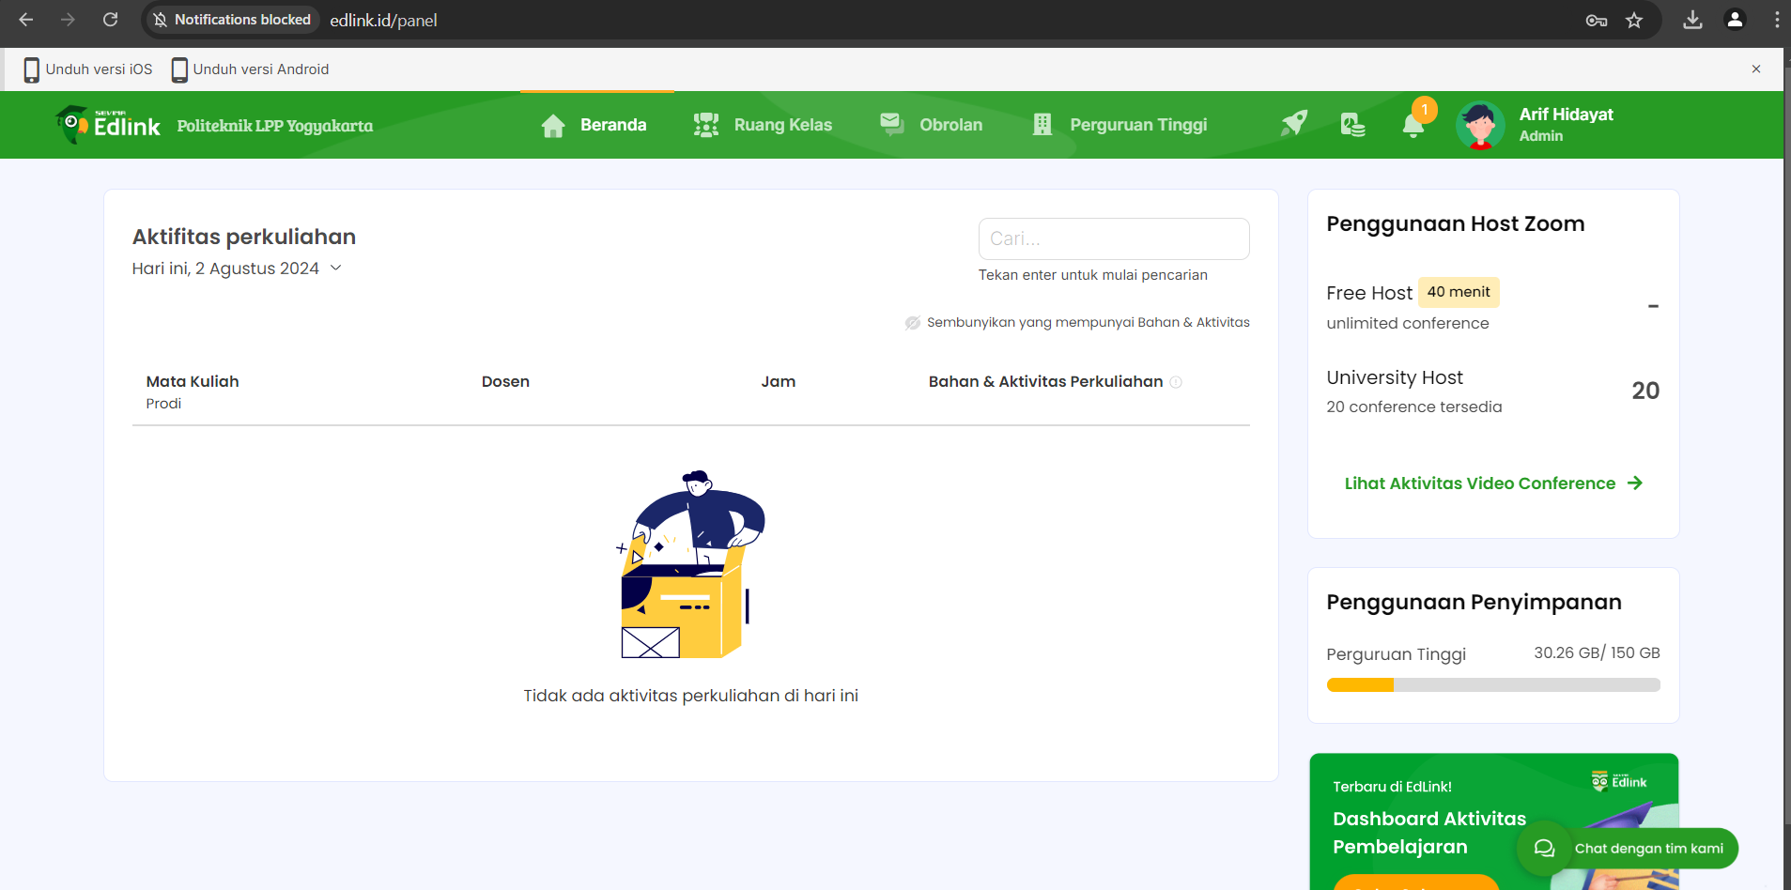
ED-LINK
Akses : edlink.id
User : arh@polteklpp.ac.id
Password : @4zl4n3019#

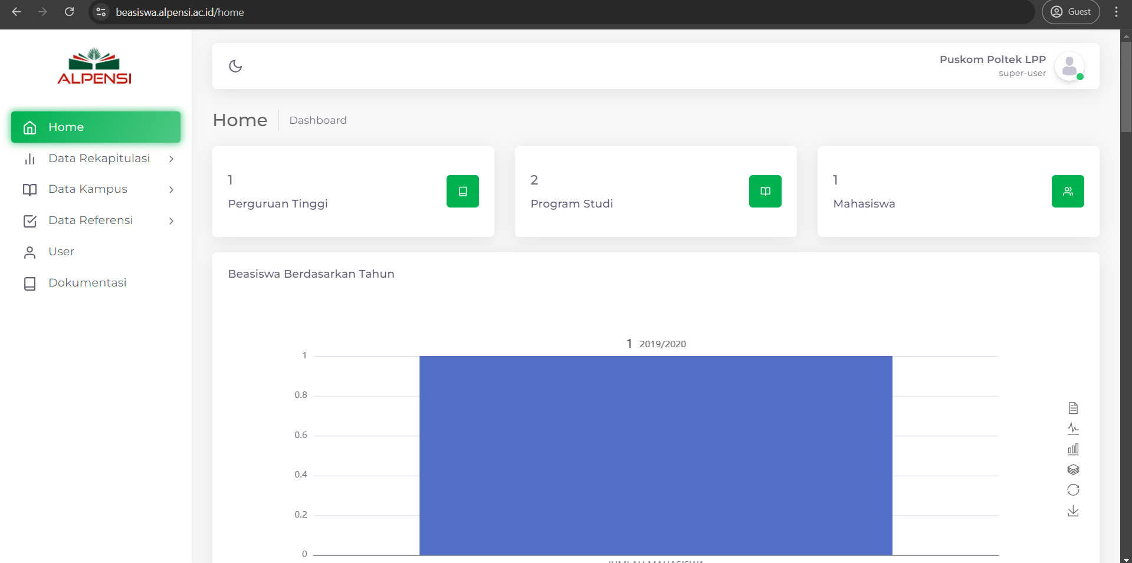
Beasiswa Alpensi
Akses : beasiswa.alpensi.ac.id
User : puskom@polteklpp.ac.id
Password : 4Lp3nsi!

WEB HOSTING DIMENSI CLOUD
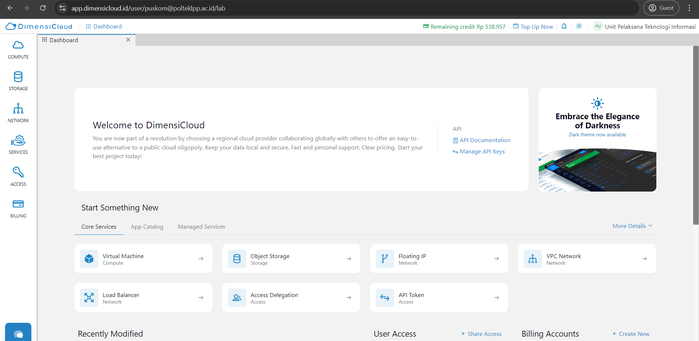
Dimensi Cloud
Akses : dimensicloud.id
Login : with Google Account Puskom

WEB HOSTING NIAGAHOSTER
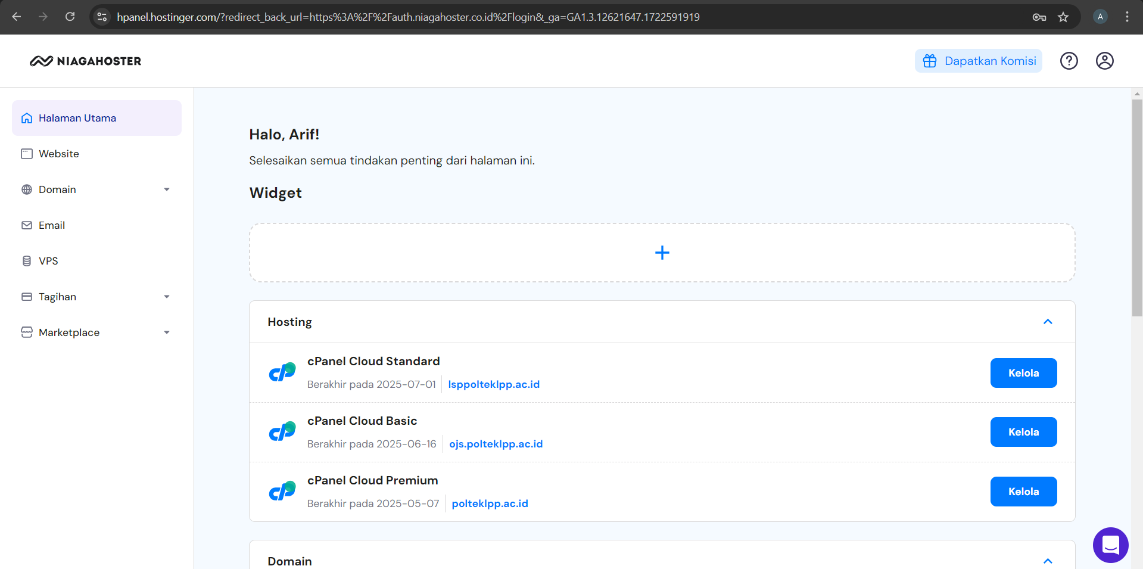
Hostinger
Akses : niagahoster.co.id
Login : arh@polteklpp.ac.id
Password : @4zl4n3019#

WEB CPANEL

CPANEL
Akses : polteklpp.ac.id/cpanel
Login : polteklp
Pass : @Sep1997##

Backup website polteklpp.ac.id dengan Backup Wizard di Cpanel. Backup benturk targz, scan dengan Malwarebytes sebelum di extrac dan sete,ah di extrac, kemudian delete semua file yg ada di cpanel -> file manager -> public_html.

WEB CPANEL

FTP
Akses : ftp.polteklpp.ac.id
Usnm : nisriina@polteklpp.ac.id
Pass : @PoltekLPP1997

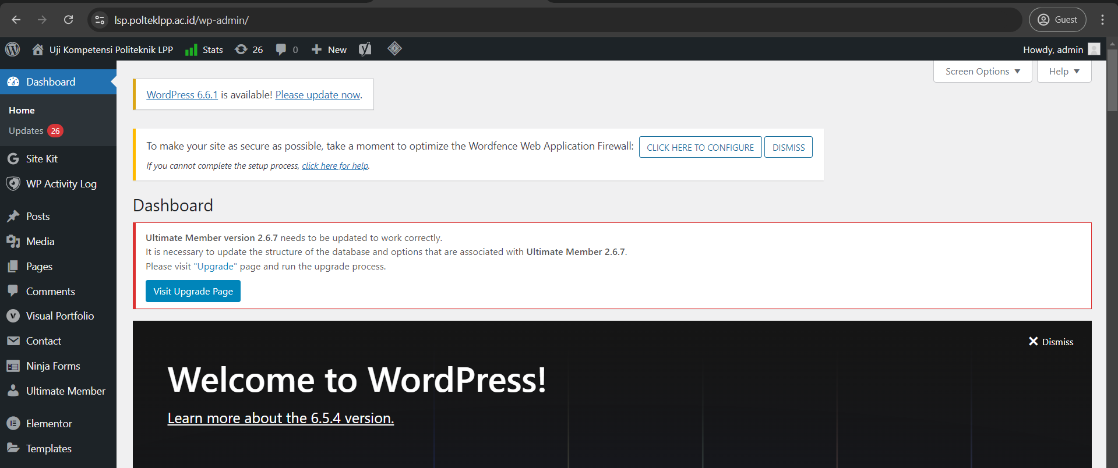
Wordpress LSP
Akses : lsp.polteklpp.ac.id/user-admin
Login : admin
Password : @PoltekLPP1997

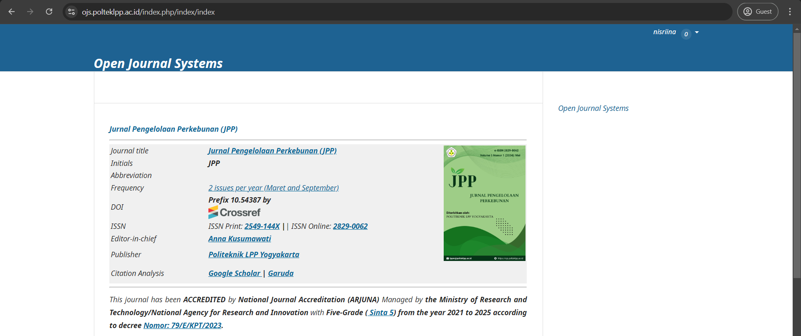
OJS
Akses : ojs.polteklpp.ac.id
Login : nisriina
Password : @PoltekLPP1997

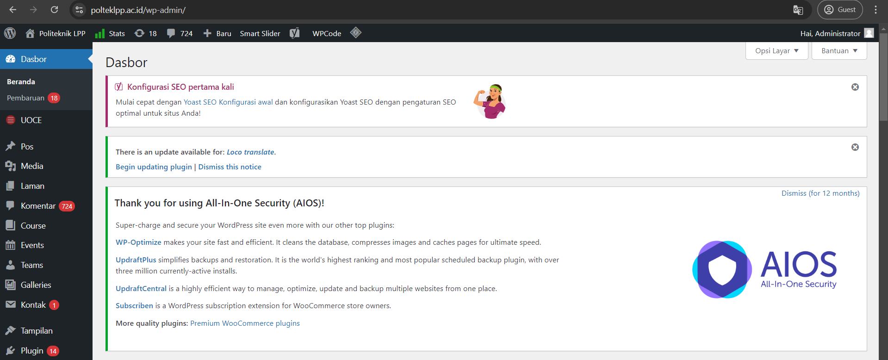
Wordpress Poltek
Akses : polteklpp.ac.id/user-admin
Login : arh@polteklpp.ac.id
Password : @PoltekLPP1997

WEB HOSTING CITRANET
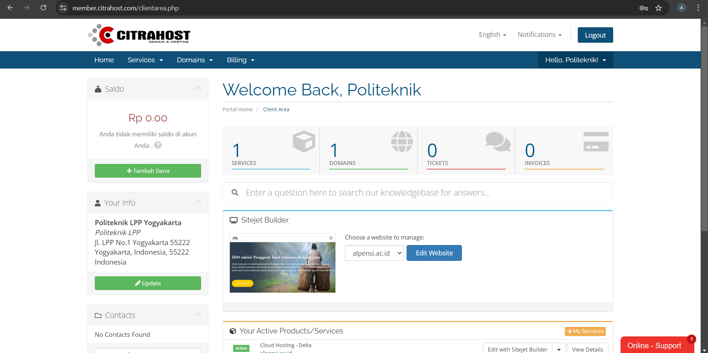
Citranet
Akses : citrahost.com
Login : arh@polteklpp.ac.id
Password : @PoltekLPP1997

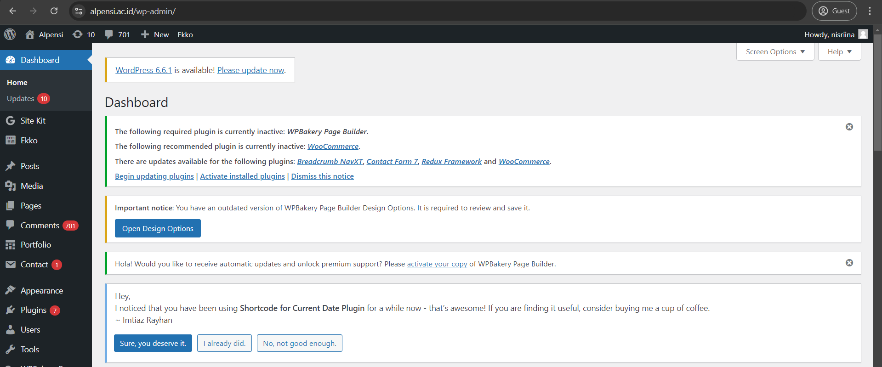
Alpensi Citranet
Akses : alpensi.ac.id/admin
Login : nisriina
Password : @PoltekLPP1997

ANYDESK PC SERVER
Controller Ubiquity : 1745411045
Password : PoltekLPP97

UKB Kemahasiswaan & UPMPI : 399428101
Legalisir & Ujian Perbaikan : 495622740
Sister : 902613943
Slims : 1791531943
Finance : 1221958078
SIM PKL : 936425511
Password (All) : PoltekLPP97

PRINTER EPSON L8050
SSID Printer : DIRECT-2F-EPSON-E0C633
Password : 87990809
Device Printer : EPSONE0C633

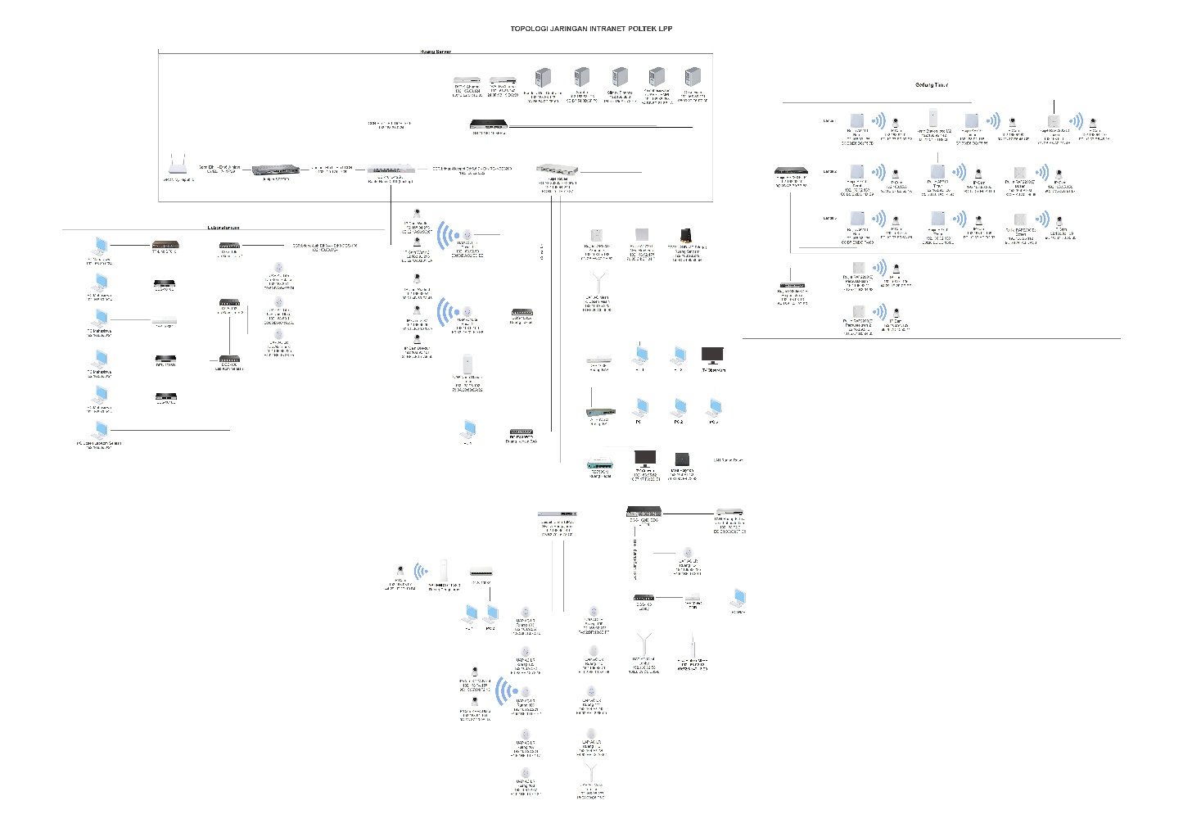
TOPOLOGI JARINGAN INTRANET POLTEK LPP

MONITORING OBSERVIUM
- Start VM Ubuntu VirtualBox (sudah startup jika PC menyala)
- Akses Observium melalui browser dengan IP 103.129. 174.21:90
- Log In Monitoring Observium
Username : admin
Password : @PoltekLPP1997#
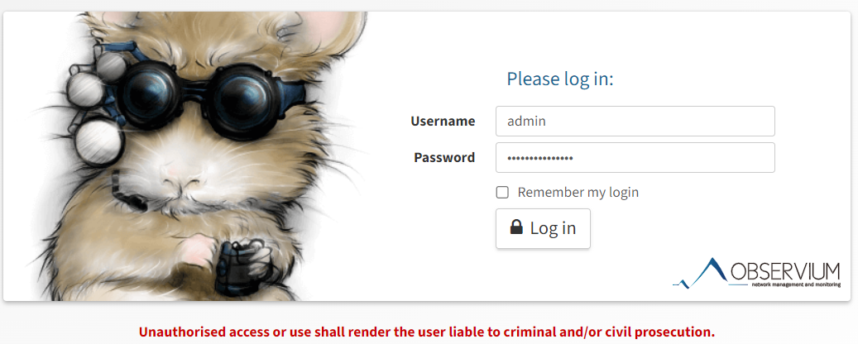
- Dashboard Monitoring Jaringan
- Device Mikrotik yang sudah terhubung dengan Observium
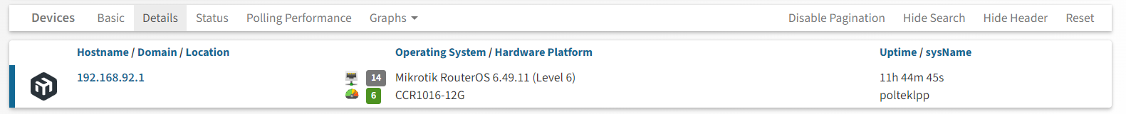
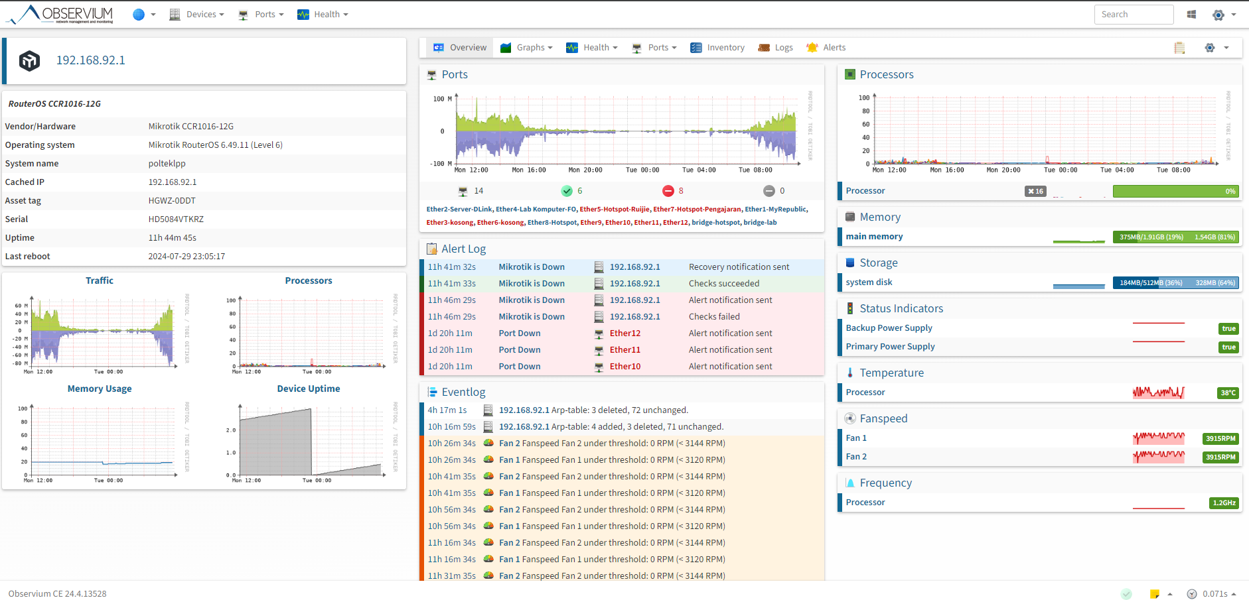

SETTING BARDI IP CAM
- Connect Bardi IP Cam dengan power
- Reset Bardi IP Cam hingga berbunyi dan lampu berkedip
- Connect Perangkat HP dengan AP terdekat
- Buka Aplikasi Bardi Smart, klik Add Device
Add Device Security IP Camera Indoor PTZs
- Scan QR ke Bardi IP Cam hingga berbunyi
- Tunggu loading hingga selesai
- Akses Bardi IP Cam

SETTING RUIJIE AP DAN SWITCH
- Connect Ruijie AP dan Switch dengan network dan power
- Lakukan IP Binding MAC Address melalui Mikrotik WInbox
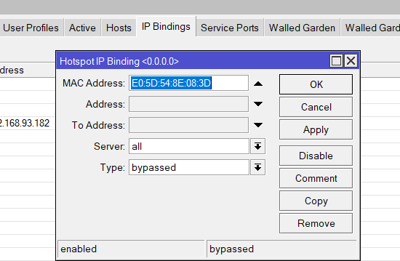
- Akses cloud-as.ruijienetworks.com atau melalui aplikasi Ruijie Reyee
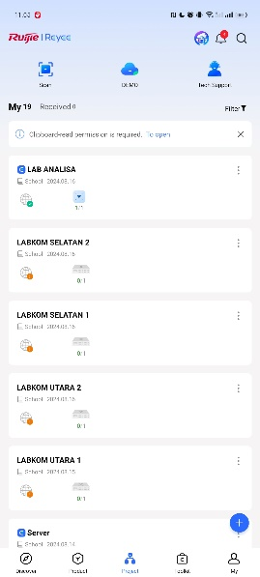
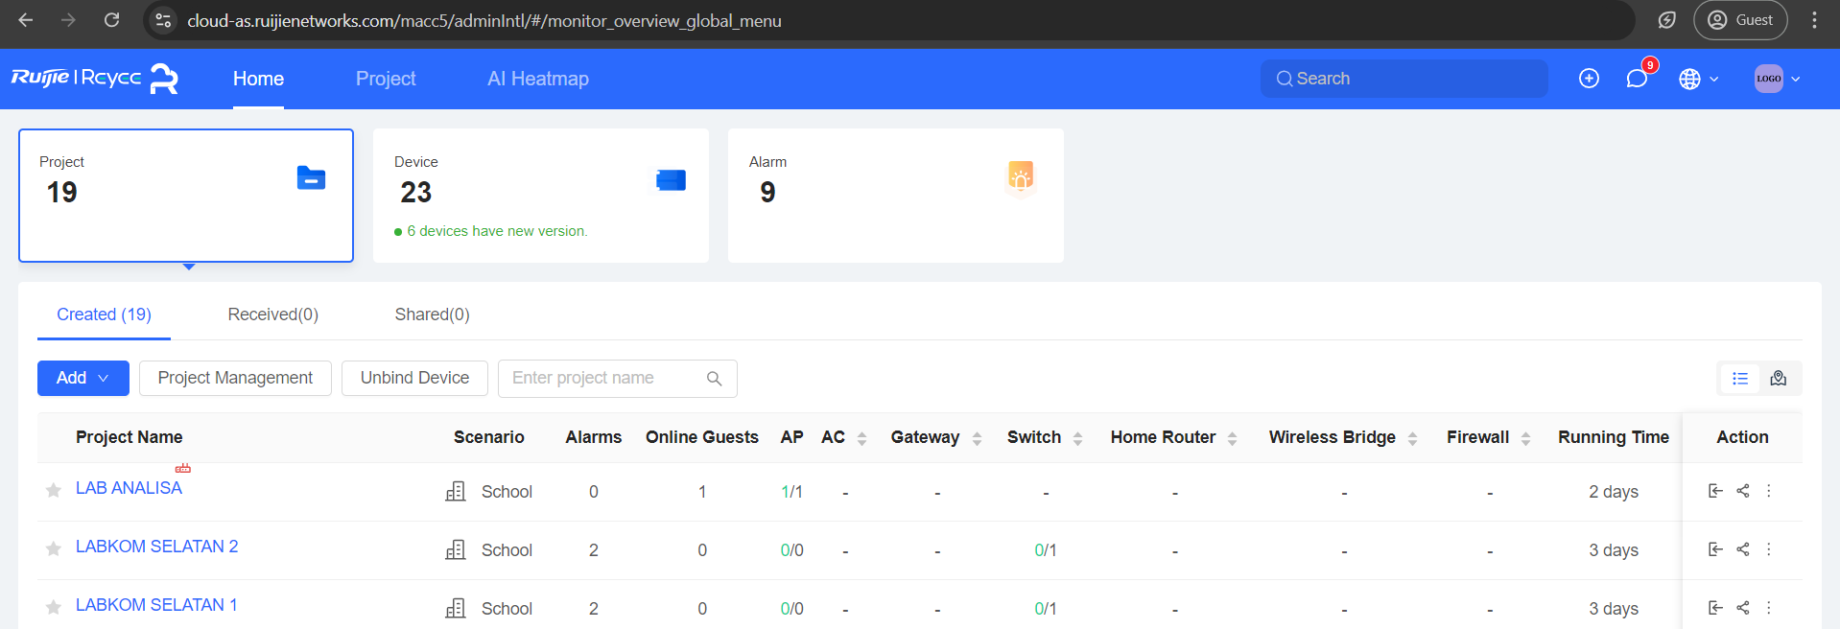
- Add New Device dengan cara scan QR atau enter manually Serial Number dan MAC Address
- Konfigurasi Ruijie AP dan Switch sesuai kriteria
- Name : Bebas menyesuaikan
- Project : Bebas menyesuaikan
- Password : Kembar111091
- Scenario : School
- Setting Channel Ruijie AP
Masuk Project Klik RAP Device Config Radio Configuration
- 2,4Ghz Channel : 1,3,6,11
- 5Ghz Channel : 36,40,44,48,52,56,60,64,149,153,157,161
- Power : Medium

SETTING NEW DEVICE UNIFI
- Connect UniFi AP dengan network dan power
- Lakukan IP Binding MAC Address melalui Mikrotik WInbox
- Akses IP Address melalui PuTTY
- Login PuTTY
- Username : ubnt
- Password : ubnt
- Lakukan Adopt Inform
set-inform https://192.168.92.121:8443/inform
- Akses https://103.129.174.19:8443 (UniFi Controller)
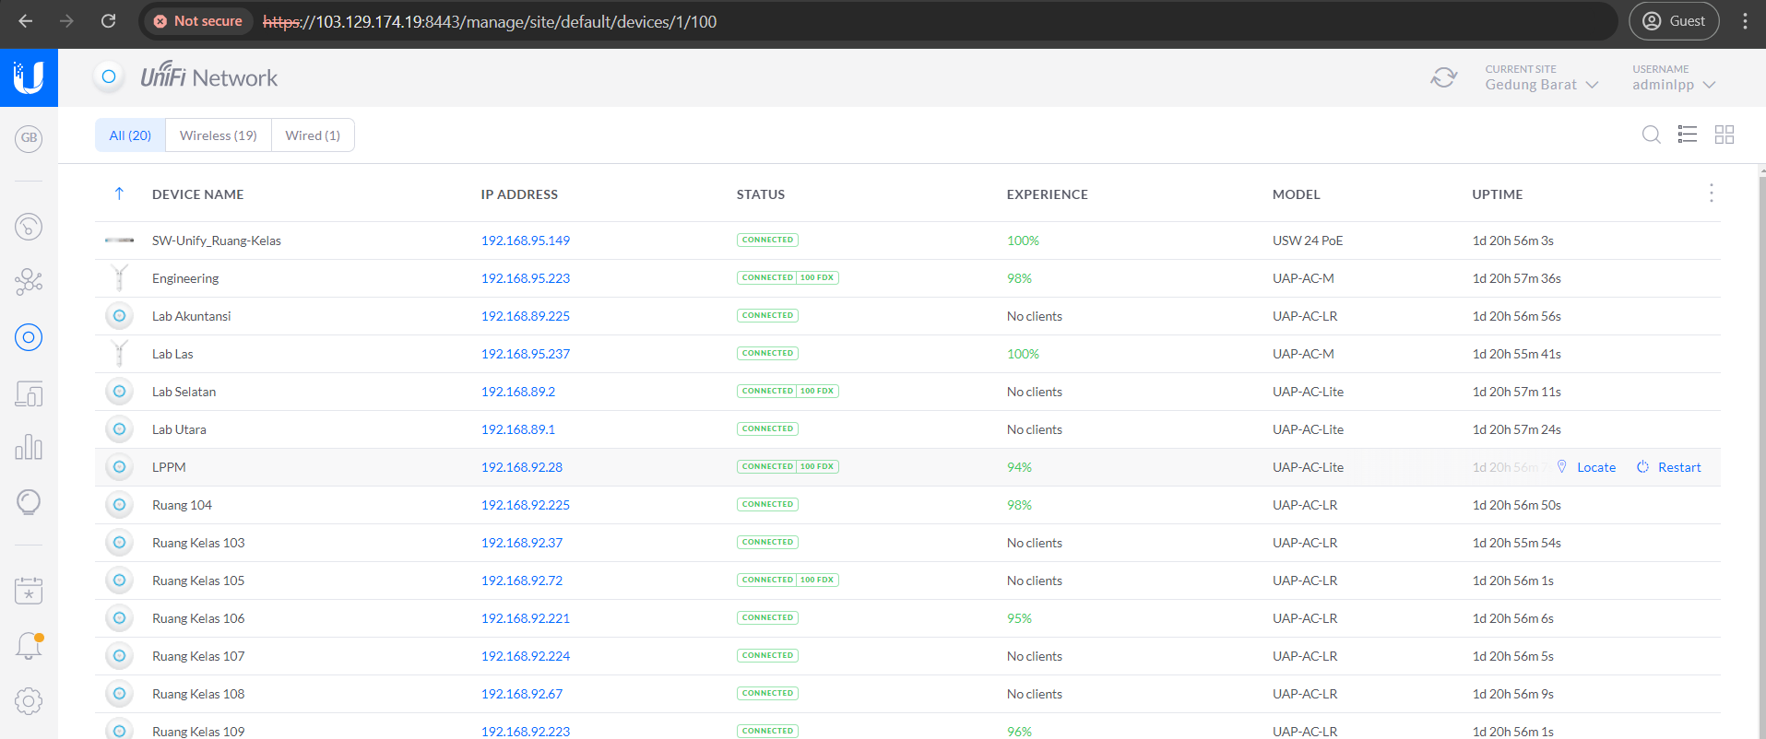
- Masuk ke tab Device, klik Adopt UniFi AP yang baru saja ditambahkan
- Beri nama UniFi AP Device sesuai kriteria
Klik UniFi AP Config
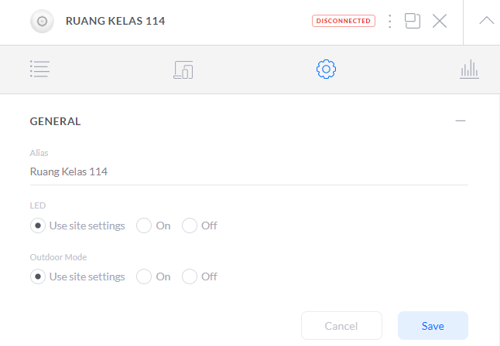
- Setting WiFi SSID
Settings Wireless Networks Create New
- Name/SSID : bebas menyesuaikan
- Security : Open
- Network : Default
- WiFi Band : Both
- Broadcasting Aps (Create New AP Group Klik device yang sudah ditambahkan Save)
- Checklist AP Group yang baru saja dibuat

